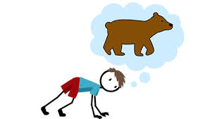

#12 Bear Crawl

MAIN ENTERENCE

#13

Bat Spins

School house



#11

Bleacher Run

Conservation District Building

Restrooms

#7

Round Bale Climb



Vendor Building

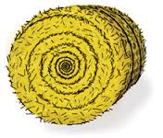

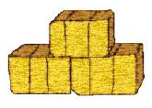

#10

Hula Hoop

#9

Square Bale Jump

Pens

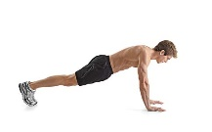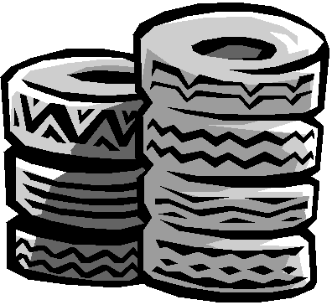

#1

Tire Roll

Pens

Pens

Open Class Building

4-H

Bldg

#6

Push-ups x 10

8th Street Entrance

#4

Tire Run

#8

Pole Weave

#5

Jumping Jacks x 10

#3

Bench Balance Beam

#2

Backwards Run